Mimico Lakeshore Network
www.mimicolakeshorenetwork.wordpress.com
lakeshorenetwork@gmail.com

November 19, 2012
Matthew Premru
Planning Department Staff
City of Toronto
399 The West Mall
Etobicoke ON

Dear Matthew and colleagues:

On behalf of the Mimico Lakeshore Network (MLN), I am providing you the considered feedback requested in response to the City Planning Department’s OPEN HOUSE gathering held at the Mimico Adult Centre on Thursday, November 8th, 2012.
We are grateful to the Planning Staff for your ongoing investment of time, energy, and financial resources in the process leading toward a Secondary Plan for the revitalization of the Mimico 20/20 Vision subject area.
We do however continue to have major concerns about the entire process:
- The Open House presentation of the consultants’ conclusions on panels without full documentation (except for the Heritage Report on line) makes it very difficult for residents to understand the full intent of the consultants; even the on-line presentation of the panels was very difficult because of the size of the files and the small font of much information;
- The time lapse between the Open House and the deadline for feedback is far too short. Time is required for considered responses. The absence of the consultants’ full report made it next to impossible to understand the thinking behind ideas presented. As well, these consultants’ reports require conversations between residents and the Planning Staff and consultants for the reports to be fully understood and the thoughts and ideas of residents to be appreciated.
It is hard to imagine how the City can call a public meeting in December to discuss a draft Secondary Plan, when the consultants’ reports have not yet been made public. We urge the meeting be delayed so that the reports to be issued can be studied and then discussed at a public meeting. Following that public meeting, another should be held to consider the draft Secondary Plan.
- The overall concern that the planning process is not rooted in the gathered opinions of those most affected (“bottom up”), but comes from “experts” and staff thereby requiring the most affected stakeholders always to react vs. contributing creatively to the overall vision shaping.
- In fact, when we consider the November 8th event’s presentation carefully, we realize that what has been reported are the Consultant’s “Big Moves” recommendations evolving from the 2009 Charette. The actual priorities as expressed by the community (listed on the feedback form) seem to have been forgotten. It is difficult to discern substantial connections between residents’ priorities and the material presented by the consultants.
The preceding comments as well as the reflections which follow are rooted in the work carried out by MLN over the last 15 months. You have on file several reports that are the product of MLN-hosted public meetings which provided opportunity for hundreds of residents to express their mind about various aspects of the Mimico 20/20 Vision project and the revitalization of the Mimico Lakeshore. The key MLN-hosted meetings reported on were November 15, 2011; February 11, 2012; and October 13, 2012.
We believe these documents report faithfully the vision of Mimico residents and would strongly emphasize the importance of rooting and shaping the Mimico Secondary Plan in these voices and the listed community priorities. As the Mimico Vision Statement indicates, Mimico residents are looking for “inclusive participation from an active mixed income community which celebrates its history, diversity, environment, arts and culture.”
You will also note that we have reviewed the consultants’ chronology of events. Some key information was omitted or overlooked and we would request strongly that the chronology be corrected as we have indicated and that this correction be carried out before the consultants’ reports are presented to the Etobicoke York Community Council and/or the Ontario Municipal Board.
Again, thanks for your partnership in this important task of seeking the revitalization of the Mimico Lakeshore.
On behalf of the Mimico Lakeshore Network,
Harry
A.H.Harry Oussoren, Convener
Mimico Lakeshore Network Steering Group

cc. Jennifer Keesmaat, Chief Planner, City of Toronto
Councilor Mark Grimes, Ward 6, City of Toronto
Councilor Peter Milczyn, Chair, Planning and Growth Committee, City of Toronto
Response of the Mimico Lakeshore Network Steering Group
To the City of Toronto OPEN HOUSE presentation of the Consultants’ Reports
Mimico 20/20 Vision project
November 19, 2012

Part I
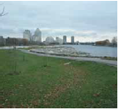
- The first picture in slide 4 appears to describe Mimico’s unique character as an established high-rise community. The towers portrayed on this slide, Grand Harbour and the Humber Bay Shores developments, are not located in Mimico 20/20 study area. The low and mid-rise apartment buildings actually located in the forefront are not visible. The viewer is left with the inaccurate impression that the unique character of Mimico is high-rise developments along the waterfront. Unlike Humber Bay Shores community, the Mimico 20/20 Secondary Plan area is located adjacent to an established low-rise community, which includes many single-family homes. This slide misrepresents Mimico as a high-rise community. We recommend that this image be removed and a more suitable image be used to convey Mimico’s unique character as a low density neighbourhood.

- Slide 5, 2nd bullet of the first paragraph, we ask that you complete the information by including the following: “The group met several times including a half-day visioning conference conducted with developers (over 100), land owners, City Staff, resident’s association members, BIA executives, and architect Jack Diamond in April 2006.” This was the first ever invitation- only meeting held on this project and the public was not invited.

- A meeting was also held in April 2009. In that instance, the Consultants met with landowners from the Mimico project area. A reference to this meeting was not included in the week-long Charette schedule (page 14, Mimico 20/20 Revitalization Action Plan). Unrecorded, separate meetings with landowners raise concerns for community members. Landowners have the most to gain from proposed changes to the area and any consultation process with this stakeholder group should be transparent. Consultants should always guard against potential conflict of interest situations by ensuring that all meetings are open to observers from the public. Records of meetings should always be made available to the public.

- The third column of slide 5 reads: “Phase Three: Secondary Plan Implementation 2011- Present”. The Secondary Plan process was not officially announced until the public meetings of May 29 /June 5, 2012, previous to this moment in time the process was referred to as a “Development Framework” for Mimico (even the feedback form for the Nov. 8 event speaks of “the proposed Mimico 20/20 development framework”). This column gives the impression that the Secondary Plan process has been on-going since early 2011, and this is not correct. The Secondary Plan was in fact announced less than six months ago.

- The third column and last bubble of slide 5 reads: “Most landowners-participants felt heights were too low”. This sentence is gratuitous and should be deleted since common sense expects landowners to seek greater values for their properties, but high financial gain is not the prime goal for undertaking the revitalization process.

- On slide 8: the MLN supports all of the City of Toronto Official Plan policies including the 1:1 Rental Replacement of units on site of the same unit size. Moreover, the MLN supports pre-construction relocation within the Mimico area to avoid having to displace children from schools and daycares and disrupting households further.

- The MLN request that a Tenant Relocation and Assistance Plan clearly be outlined in the Mimico 20/20 Secondary Plan policies so that all residents and especially those most affected will be aware of the City’s mandated provisions.

- The MLN expects the Mimico 20/20 Secondary Plan to clearly define 1, 2 and 3 bedroom units.

- The shadow impact picture on slide 11 is out of focus and inadequate. Please provide clear shadow impact scenarios for different times of year and day, particularly for December and March. 10.

- The Secondary Plan which is produced from this project needs to be accompanied by a broadly based Implementation Team representing the diversity of the community and other stakeholders. The aim would be to ensure faithful adherence to the principles, values, and objects articulated by the Secondary Plan for the genuine revitalization of the Mimico community.

Part II

- Transportation and Traffic: It is difficult to credit that doubling the number of residential units in the area, adding traffic from new developments at Humber Bay Shores, Park Lawn and Mystic Point will result in only an increased delay from ‘good/satisfactory ’ to ‘moderate’ at the intersections of Lake Shore Blvd/Superior and Lake Shore/Mimico Avenue.
Since the Heritage report is the only background study available at this time, it is not possible for community members to understand how adding potentially 2500 residential units plus commercial activity would result in so little impact on car traffic in the area. One can only question the underlying assumptions.

In general, we see little evidence that transportation has really been considered for the study area. Bicycle lanes are not clearly identified or non-existent and there is no mention of public transportation improvements either, which again makes it difficult for community members to comment on transportation infrastructure for the study area.
We note with concern that already the narrowness of the recently opened path in the linear park is leading to conflict between pedestrians and cyclists.

Part III – Precinct Reviews

General

We recommend that height across the study area exclude tall buildings and redevelopment projects be restricted to 8 storeys and in exceptional situations for aesthetic or strategic reasons up to 12 storeys be permitted. For support of height restrictions, see Mimico Residents Association survey at http://www.mimicoresidents.ca/mimico-2020-survey-results. and the MLN’s Mimico Residents Speak report at https://mimicolakeshorenetwork.files.wordpress.com/2012/04/community-workshop-feb-11-2012.pdf)

Indications of density (FSI) are needed to better understand what the consultants are proposing.

- Slide 1 in Part III refers to a Precinct A and B and shows an illustrative development framework.

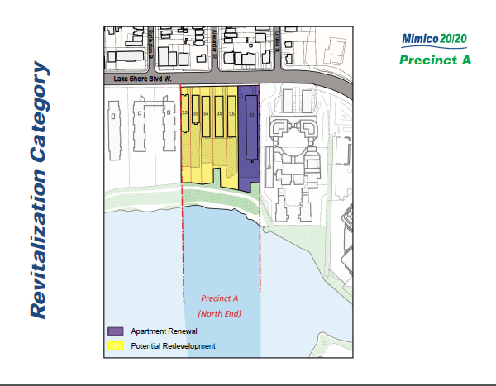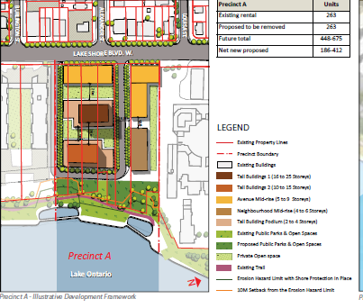
May/June 2012 November 8, 2012

Precinct A: 2301 Lake Shore (building in blue) was never expected to be torn down and rebuilt. It was always seen as an opportunity for tower renewal.

It is our understanding that the criteria used to determine recommendations for particular land parcels is the quality of the building stock, as illustrated in the Consultant’s 2009 report entitled Mimico 20/20 Revitalization Action Plan , illustrated below:

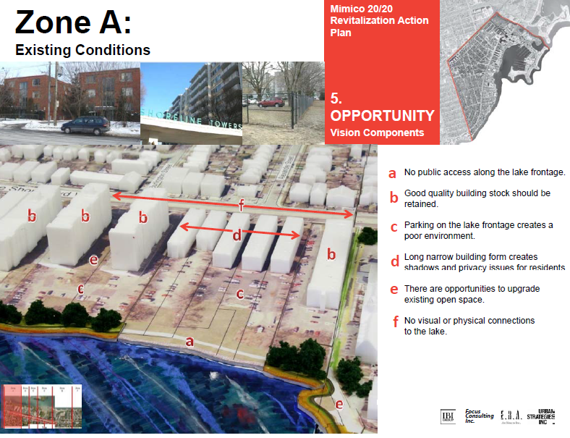

The apartment building located at 2301 Lake Shore Blvd. W., which was previously indicated as being retained, is now shown as a redevelopment property, but without providing a rationale. We highly recommend that the criteria used to recommend change in the area be maintained and that the property at 2301 be retained for the quality of its building stock.

The overall density proposed for Precinct A is approximately 133 units per acre.
MLN recommends strongly Consultants provide some other form of density measure such as an FSI and provide strict height limits and disallow Section 37 interventions for all developments in the secondary plan area (except to foster family-oriented accommodation).

- Precinct B (slide 1): this precinct at the May/June 2012 public meetings boasted infill development, which we felt was a gentler, better form of redevelopment supporting tower renewal initiatives in the area. Although the Consultants claim that this can still happen in the future, barring the extension of the road, they no longer seem to be allocating units and supporting tower renewal initiatives for this Precinct.

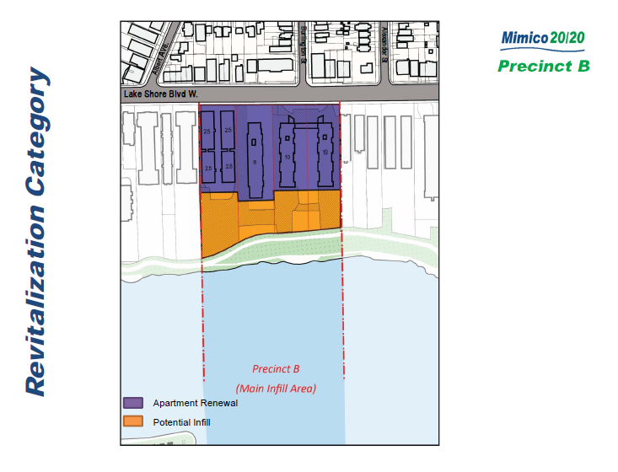 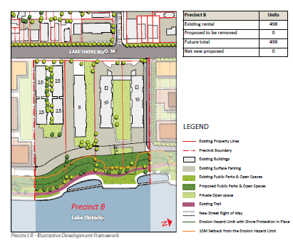 May/June 2012 November 8th, 2012

The 2008 Study Area Priorities recommends: “to maintain a mix of housing types and tenures and explore options to upgrade current rental housing stock.” Under Housing in Mimico (Part 1 slide 8) it is stated: “Affordable ownership housing and non-profit co-operative housing will be encouraged”. The plans at the May/June 2012 showed many infill projects, including density allotment on the Killcooley Housing Co-op property.
In the November 8th proposal, the Consultants no longer recommend infill residential units for the co-op site.
MLN recommends an increased density allocation on the site of the Killcooley Co-op in the interests of fostering affordable housing.

The current density for Precinct B is 61 units per acre as opposed to Precinct A where it is more than double at 133 units per acre.

- Precinct C

The Consultants are recommending redevelopment rather than infill for Precinct C. We have been of the understanding from the very start of this project that the decision to recommend redevelopment of a property was based on an assessment of the quality of the building stock. In this instance, we believe that the existing apartment buildings are of good quality and should be maintained. Options to upgrade existing apartment buildings are identified as a priority in the 2008 Study. Tower renewal is a form of upgrade and should be supported in the redevelopment of the area.

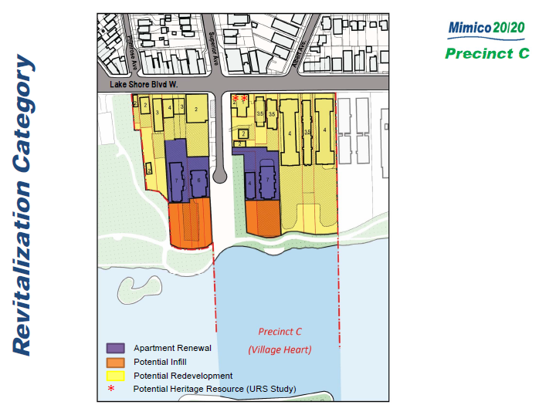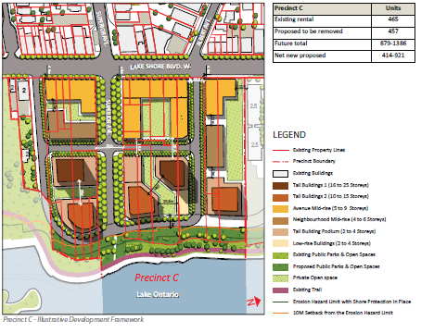
May/June 2012 November 8, 2012

We propose mid-rise infill development at this location. We also recommend that the location of the existing public park be clearly identified in the plan. In general, we support the proposed road pattern in this area provided it is not built on lands designed as open space or parkland.

We do not believe that Superior is “the village heart”. We believe that Superior is wide probably because there is a creek beneath it – which some are calling to be unearthed again. The Village Heart is much more logically located in Precinct D, because the heart of a community is characterized by open, public spaces and amenities, including parkland. Mimico Avenue has a history of being the village “high street”.

- Precinct D

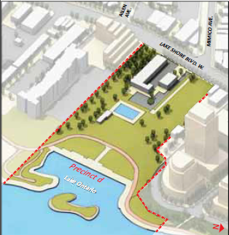
Precinct D is an opportunity to present some real improvements to the public realm in an already (12 acres) parkland-deficient area. This area needs to become the Village Heart. This new plan for the whole study area, if built out to its maximum, would allow 2573 new residential units. The Consultants suggest improvements to the overall landscape quality and function of the park and an upgrade of the existing facilities (such as the pool). As recommended by the community in the Mimico 20/20 Study Priorities: “expand and improve existing parks and recreational facilities with a focus on waterfront locations” This community is looking for real public realm improvements to the area such as a large indoor swimming pool facility, equipped with gym, yoga, dance studios and meeting rooms on the second floor along with a large community room for local events. Store Front Humber’s services to seniors and disabled persons need to radiate from this area. The shopping plaza just west of Store Front Humber needs to be expropriated for community space. Overall, improvements and amenities such as these would help attract young families and strengthen the diversity of the area.

- Precinct E

We support the Consultant’s decision to remove the road patterns in this Precinct. We note that there are two co-ops located in this Precinct and small infill projects should be allowed in this area.

- Precinct F

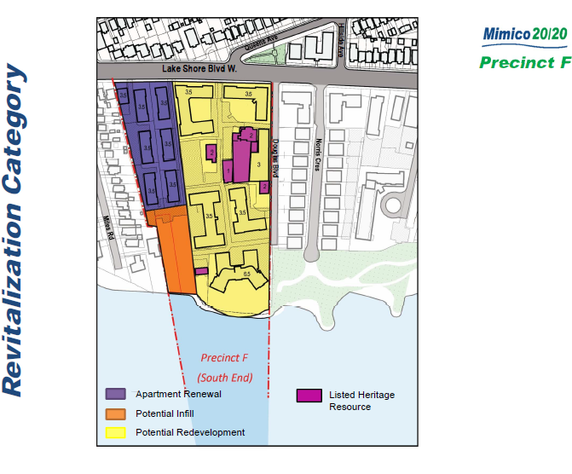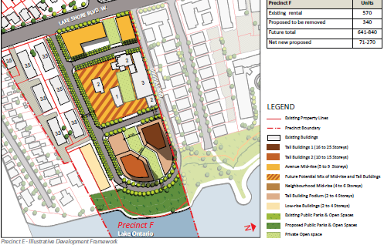
May/June2012 November 8, 2012

The Consultants are recommending that 340 rental units be replaced and that an additional 270 residential units be built for a total of 840 dwelling units in this Precinct. MLN supports this proposal.

12. Precinct G

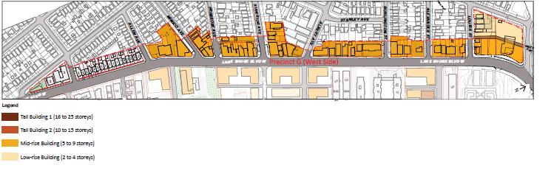
May/June 2012
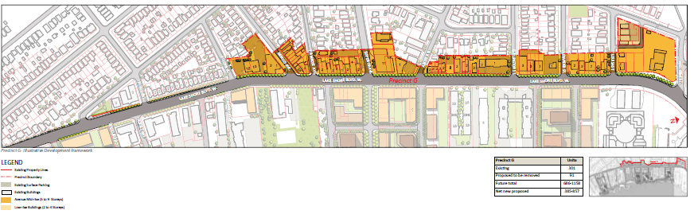

The focus at public meetings has always been on the area located east of Lake Shore Blvd, very little was said about the Avenues strip located west of Lake Shore Blvd. The proposed addition of 686-1158 units on the west side of Lake Shore was never really discussed at public meetings. We note that this area would require the implementation of the Mid-Rise Building guidelines and wish to clarify that is it also adjacent to a single family neighbourhood; two-storey homes located immediately behind properties facing LakeShore Blvd. W. Precinct G also includes a large (practically vacant) 4 acre site, as well Connaught Hall Mason Temple which is nominated for designation as a Heritage building.

MLN recommends that Precinct G receive the same kind of detailed planning as those Precincts located east of Lake Shore Blvd. For example, the Consultants need to identify the 91 rental units they recommend should be replaced as well as the location of the proposed new units.
The community wanted to see more beautification measures undertaken on public lands, sidewalk improvements, better signage and lighting (as per the 2008 Priorities) as well as more support for local businesses by promoting the unique assets of the area more aggressively.

Commercial and Office land designations would ensure the creation of employment opportunities in the area. Without the opportunity for jobs, the area becomes another transportation dependent community with no real economic activity. People will have to travel outside the community to work.

Table 1 – Mimico 20/20 Secondary Plan showing future total number of residential units for
each Precinct

Precinct Existing Rental Units removed Future Total Net new proposed

A 263 263 448 - 675 186 - 412
B 498 0 498 0
C 465 457 879 -1386 414 - 921
D 2 0 2 0
E 648 8 700 - 761 52 - 113
F 570 340 641 840 71 - 270 G 311 91 686 -1158 385 - 857

Total 2757 1159 3354 -5320 723 – 2573

Conclusion

MLN believes that the process is not yet ripe for a Secondary Plan to set the norms for the revitalization of Mimico. Key information has not yet been made public and still needs to be digested and discussed. Opportunities for thoughtful and critical conversation and innovative idea-sharing still need to happen. Casting current ideas in legislative “stone” is premature.

The Mimico Vision Statement and the Priorities of residents remain thel key road maps along the way. Residents, planners, property and business owners, and community leaders can work in respectful partnership to create the new Mimico within the City of Toronto.

Mimico Lakeshore Network

General Recommendations re Mimico 20/20 Vision:

- Public interest to be respected over private or corporate interests
- Create an implementation team and include local residents/business groups, etc.
- No tall buildings – Mid-rise buildings and 12 storeys for exceptional design
- Place strict height restrictions – no Section 37 interventions (family sized units only)
- Maintain a mix of housing types and tenures; create affordable family-sized units
- Explore options to upgrade current rental housing stock – more tower renewal
- No roads on lands designated as open spaces/parkland
- Require a 5% parks contribution or 5% cash-in-lieu
- All open space in the area to become parkland
- Create community and neighbourhood parks
- Create a Village Heart with a large recreational facility at Amos Waites Park (include Storefront Humber); purchase the plaza
- Improve public realm and parks; establish principles to guide future development
- Clearly identify and widen bicycle trails where necessary
- Address public transit needs (bring back the 507)
- Identify and provide for community needs (i.e. social services, public amenities)
- Create opportunities for employment; identify office and commercial land uses

