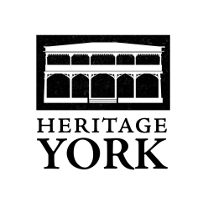

Membership/Renewal Form
2017

Your membership is vital to our organisation. Please complete the below form in full and return it with your membership fee. This information is only for our records and will not be given or sold to any other group, individuals or organisations.
Our annual membership fees are: Individual $15; Family $25; Student/Senior $10.
A membership card, if requested, will be issued to you upon payment of your annual membership fee. For any donation of $10.00 or more, a charitable donation receipt for Canadian income tax purposes, will be issued. Please make cheques/money orders payable to Heritage York.
The Heritage York Board of Directors thanks you for your membership and for your interest in our work.

…………………………………………………………………………………………………………………….
PLEASE PRINT CLEARLY

Name(s): ________________________________________________________________________

Address: _________________________________________________________________________

_________________________________________________________________________

Telephone: ________________________________ Mobile: ________________________________

E-mail address: ___________________________________________________________________

My/our Heritage York membership is for:
Individual $15.00 $ _______________
Family $25.00 $ _______________
Student/Senior $10.00 $ _______________
Donation $ _______________

TOTAL $ _______________

Please make cheque or money order payable to Heritage York and forward it to:
4066 Old Dundas Street, York, ON M6S 2R6

